Towards Quantum Marching Cubes: Quantum Vertex Classification
A Thesis submitted to the faculty of
San Francisco State University
In partial fulfillment of
the requirements for
the Degree
Master of Science
In
Computer Science
by
Brandon R.K.Watanabe
San Francisco, California
May 2026

Copyright by
Brandon R.K. Watanabe
2026

Certification of Approval
I certify that I have read Title of Culminating Experience by First Middle Last Name, and that in my opinion this work meets the criteria for approving a thesis submitted in partial fulfillment of the requirement for the degree (Example) Master of Science in Biology: Conservation Biology at San Francisco State University.

Name of the professor, Choose degree
Click to choose the faculty rank,
Thesis Committee Chair

Name of the professor, Choose degree
Click to choose the faculty rank

Name of the professor, Choose degree
Click to choose the faculty rank

Name of the professor, Choose degree
Click to choose the faculty rank

Abstract
Begin your abstract here.

Insert a section break at the end of the Abstract by placing your cursor after the final punctuation and going to Layout > Breaks > Next Page (under Section Breaks). For corresponding screenshots, please consult Microsoft’s support page.

Preface
Including a Preface for your work is optional. If you do not have one, please delete this page.

[Insert a page break at the end of the Preface by placing your cursor after the final punctuation and going to Insert > Page Break.}

Acknowledgements
Normally the Acknowledgements section gives you the opportunity to thank those to whom you are indebted for assistance in the project. This should be done briefly and in good taste.

[Insert a page break at the end of the Acknowledgements by placing your cursor after the final punctuation and going to Insert > Page Break.]

Table of Contents
Certification of Approval 2
Abstract 3
Preface v
Acknowledgements vi
Table of Contents vii
List of Tables ix
List of Figures x
List of Appendices xi
Introduction 1
Chapter 1: Background Literature Review 2
1.1 Vertex Classification 2
1.2 Quantum Computing Basics 2
1.3 Quantum Image Processing 2
1.4 LBNL Quantum Algorithms 2
QCrank 2
EHands 2
1.5 Qiskit 2
Chapter 2: Implementation 2
2.1 Overall Circuit Architecture 2
2.2 EHands Arithmetic 2
2.3 Classification 2
Chapter 3: Evaluation and Results 3
3.1 Computational platform and Software Environment 3
3.2 Methodology 3
3.3 Experiment 1: Verification of Correctness of Quantum Arithmetic Computations 3
3.4 Experiment 2: Testing Isovalue Weight Encoding 3
3.5 Experiment 3: Comparison of Tiling Sizes for a Fixed Size Image 3
3.6 Experiment 4: Shift to 3D data 3
3.7 Experiment 5: Running on Real Quantum Hardware 3
3.7 Findings and Discussion 3
Chapter 4: Conclusion 4
FORMATING GUIDE CHAPTER TO REMOVE LATER 5
SUBHEADER 3 5
Chapter Heading 4 (Sub-subheading) 7
References/Bibliography/Works Cited 9
Appendix/Appendices 10

List of Tables
Table 1. Number of Students, 2016-2019 6
Table 2. Responses to Survey Question 1 7

List of Figures
Figure 1. A sketch of Doullens town hall 4
Figure 2. Marine Algae in Sweden 7

List of Appendices
Appendix A: List of California State University Campuses 9
Appendix B: Abbreviations of California State University Campuses 10

Introduction
Lorem ipsum dolor sit amet, consectetuer adipiscing elit. Maecenas porttitor congue massa. Fusce posuere, magna sed pulvinar ultricies, purus lectus malesuada libero, sit amet commodo magna eros quis urna. Nunc viverra imperdiet enim. Fusce est. Vivamus a tellus.

Chapter 1: Background Literature Review

1.1 Vertex Classification
Pellentesque porttitor, velit lacinia egestas auctor, diam eros tempus arcu, nec vulputate augue magna vel risus. Cras non magna vel ante adipiscing rhoncus. Vivamus a mi. Morbi neque. Aliquam erat volutpat. Integer ultrices lobortis eros.
Pellentesque habitant morbi tristique senectus et netus et malesuada fames ac turpis egestas. Proin semper, ante vitae sollicitudin posuere, metus quam iaculis nibh, vitae scelerisque nunc massa eget pede. Sed velit urna, interdum vel, ultricies vel, faucibus at, quam. Donec elit est, consectetuer eget, consequat quis, tempus quis, wisi. In in nunc. Class aptent taciti sociosqu ad litora torquent per conubia nostra, per inceptos hymenaeos.
Figure 1. A sketch of Doullens town hall
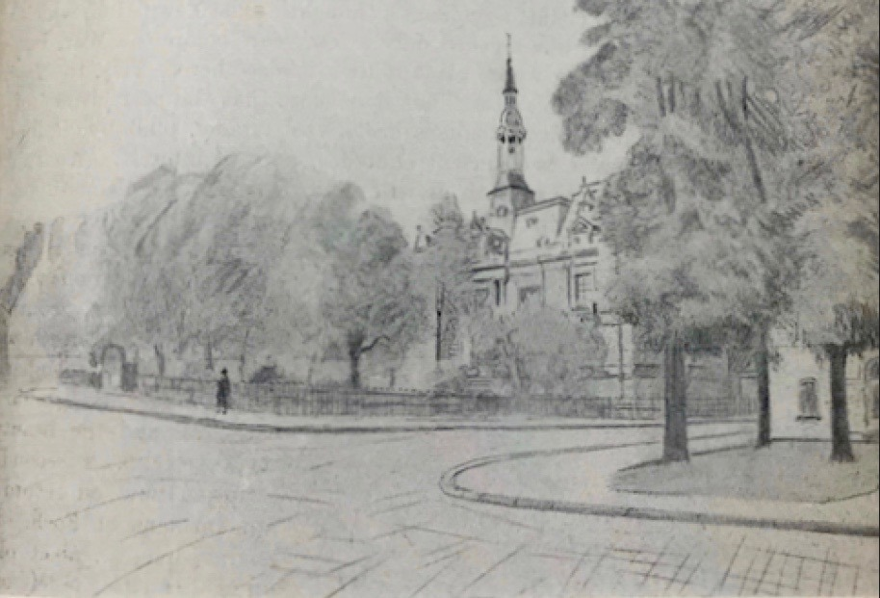
This sketch by W. Basil Worsfold was first published in "United Empire," Volume XX, London: Isaac Pitman, 1929, pg. 237. The image is in the public domain.
Donec ullamcorper fringilla eros. Fusce in sapien eu purus dapibus commodo. Cum sociis natoque penatibus et magnis dis parturient montes, nascetur ridiculus mus.

1.2 Quantum Computing Basics

1.3 Quantum Image Processing

1.4 LBNL Quantum Algorithms

QCrank

EHands

1.5 Qiskit

Chapter 2: Implementation

2.1 Overall Circuit Architecture
The first stage is to transfer the classical input data into the QPU, via an encoding mechanism that will initialize a quantum circuit in a way that the quantum state contains a representation of the input field. Let's refer to this stage as $\left|E_{s}\right\rangle =U_{e}{\left|0\right\rangle }^{⊗n}$ where $U_{e}$ is the unitary transformation that takes us from a bare circuit on $n$ qubits to a state where the classical input data is encoded into a quantum state$\left|E_{s}\right\rangle$ The number $n$ of qubits needed is a function of the size of the input data field and the specific encoding method.
We will then perform the $f: R → \{0, {1\}}^{1}$ transformation. We define the encoding stage as $\left|C_{s}\right\rangle =U_{c}\left|E_{s}\right\rangle$ where $U_{c}$ is the unitary transformation that performs the classification of the state $E_{s}$producing a new state $C_{s}$.
Finally, we need to measure the quantum state $C_{s}$ to obtain the solution to the problem.

Quantum Data Encoding
Our input data is a 2D image of size $W×H$ which is converted to grayscale pixel values and normalized to the range $\left[-1,1\right]$. We divide the image into $T_{w}×T_{w}$ tiles which are flattened in row-major order into a 1D array for encoding via QCrank \cite{balewski:monarq:2026}. QCrank encodes $n_{d}×2^{n_{a}}$ real-valued samples through angle encoding where $n_{d}$ is the number of data qubits and $n_{a}$ is the number of address qubits. When encoding 1D data, QCrank calls for use of $n_{d}=1$ data qubit and $n_{a}=\left[\log_{2}{L}\right]$ address qubits where each element $x_{i}$ is stored at address $i$.
Our implementation uses a $64×64$ pixel input image and tile size of $4×4$. The image is tiled to reduce qubit requirements and circuit depth, enabling separate circuit evaluation for each tile on current hardware. For each $4×4$ tile, $L = 16$; therefore, $n_{a}=4$ address qubits and one data qubit for the data encoding. Each $x_{i}$ value is mapped to a rotation angle using $R_{y}\left(θ_{i}\right)$ where $θ_{i}=\arccos\left(x_{i}\right)$ following the expectation value encoding (EVEN) scheme \cite{balewski2025ehandsquantumprotocolpolynomial}, which maps each normalized scalar $x_{i}∈\left[-1,1\right]$ to a qubit rotation such that the Pauli-Z expectation value (EV) reproduces the original sample, that is $\left\langle Z\right\rangle =x_{i}$.

Quantum Vertex Classification
In classical marching cubes, each vertex value $x_{i}$ is compared against an isovalue $t$ to assign a binary classification: $x_{i}≥t$ indicates inside, and outside otherwise. Equivalently, this corresponds to evaluating the sign of $x_{i}-t$.
In the quantum formulation, we implement this comparison using the weighted addition operator from the EHands protocol \cite{balewski2025ehandsquantumprotocolpolynomial}. An ancilla qubit is added to encode the isovalue threshold $t$ using the same EV encoding as the data qubit, $R_{y}\left(θ\right)$ with $θ=\arccos\left(t\right)$.
A negation operator is then applied so that the following EHands weighted addition acts as a subtraction between the encoded vertex value and the isovalue. Applying the EHands addition operator to the data qubit and ancilla yields a transformation on the data qubit where the EV found through measurement represents
$$y_{i}=\frac{x_{i}-t}{2}$$
We estimate the EV of the resulting data qubit. The sign of the EV determines classification: a positive EV indicates an inside classification, $x_{i}-t≥0$, while a negative EV indicates an outside classification, $x_{i}-t<0$. This part is done classically as it is performed after measurement.
This quantum approach applies the weighted subtraction simultaneously across all addresses in superposition of the encoded tile.

Measurement and Readout
The final stage consists of extracting classical information from the quantum state $|C_s⟩$ via measurement. Quantum measurement yields a single sample from the state’s probability distribution, meaning that a single circuit execution cannot estimate the expectation values required for classification.

Instead, the circuit is executed repeatedly over many shots. Each shot produces a binary measurement outcome, which are aggregated to estimate the EV of the data qubit for each encoded data. The sign of this estimated expectation value determines the final classification.
The input data is encoded in superposition across address qubits. To recover our results, we group measurement outcomes by address and average over shots. The accuracy of the classification depends on the number of shots used to estimate expectation values.
The number of shots required depends on the closeness of $x_{i}$ to $t$, with values near the threshold requiring more samples to determine the correct sign with high confidence.

Tiling
Current quantum hardware puts constraints on circuit width and depth, which impacts the scalability of data processing. Encoding an entire $64×64$ image into a single quantum circuit would require a large number of qubits and a deep circuit, leading to significant noise on current NISQ devices.
To address these constraints, we use a tiling approach in which the input image is split into smaller tiles. In this work, we split the image into $4×4$ tiles. Each tile is processed on independent circuits, which reduces the number of required qubits and shortens circuit depth to make execution feasible on available quantum hardware. Each tile is encoded, processed, and measured separately, producing a subset of classification results. These are stitched back together in a classical post-processing step to reconstruct the full classification.
Since quantum computations require many shots to give accurate results, there is a tradeoff between computational cost and classification accuracy.

2.2 EHands Arithmetic

EHands Weighted Summation

2.3 Classification
Placeholder

Chapter 3: Evaluation and Results

3.1 Computational platform and Software Environment

3.2 Methodology

3.3 Experiment 1: Verification of Correctness of Quantum Arithmetic Computations

3.4 Experiment 2: Testing Isovalue Weight Encoding

3.5 Experiment 3: Comparison of Tiling Sizes for a Fixed Size Image

3.6 Experiment 4: Shift to 3D data

3.7 Experiment 5: Running on Real Quantum Hardware

3.7 Findings and Discussion

Chapter 4: Conclusion

FORMATING GUIDE CHAPTER TO REMOVE LATER

SUBHEADER 3
Vivamus vitae massa adipiscing est lacinia sodales. Donec metus massa, mollis vel, tempus placerat, vestibulum condimentum, ligula. Nunc lacus metus, posuere eget, lacinia eu, varius quis, libero. Aliquam nonummy adipiscing augue. Lorem ipsum dolor sit amet, consectetuer adipiscing elit. Maecenas porttitor congue massa. Fusce posuere, magna sed pulvinar ultricies, purus lectus malesuada libero, sit amet commodo magna eros quis urna. Nunc viverra imperdiet enim.
Table 1. Number of Students, 2016-2019
Year | Number of Students
2016 | 12,923
2017 | 13,012
2018 | 11,065
2019 | 12,743
Table 1. A caption is optional, but it can be helpful to summarize the data and explain how a table relates to the surrounding text.
Fusce est. Vivamus a tellus. Pellentesque habitant morbi tristique senectus et netus et malesuada fames ac turpis egestas. Proin pharetra nonummy pede. Mauris et orci. Aenean nec lorem. In porttitor.
Donec laoreet nonummy augue. Suspendisse dui purus, scelerisque at, vulputate vitae, pretium mattis, nunc. Mauris eget neque at sem venenatis eleifend. Ut nonummy. Fusce aliquet pede non pede. Suspendisse dapibus lorem pellentesque magna. Integer nulla. Donec blandit feugiat ligula.
Table 2. Responses to Survey Question 1
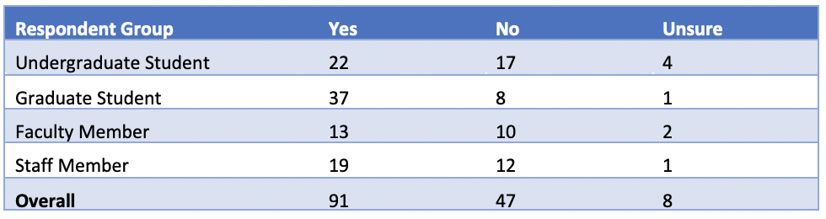
Table 1. A caption is optional, but it can be helpful to summarize the data and explain how a table relates to the surrounding text.
Donec hendrerit, felis et imperdiet euismod, purus ipsum pretium metus, in lacinia nulla nisl eget sapien. Donec ut est in lectus consequat consequat. Etiam eget dui. Aliquam erat volutpat. Sed at lorem in nunc porta tristique. Proin nec augue. Quisque aliquam tempor magna. Pellentesque habitant morbi tristique senectus et netus et malesuada fames ac turpis egestas.
Figure 2. Marine Algae in Sweden
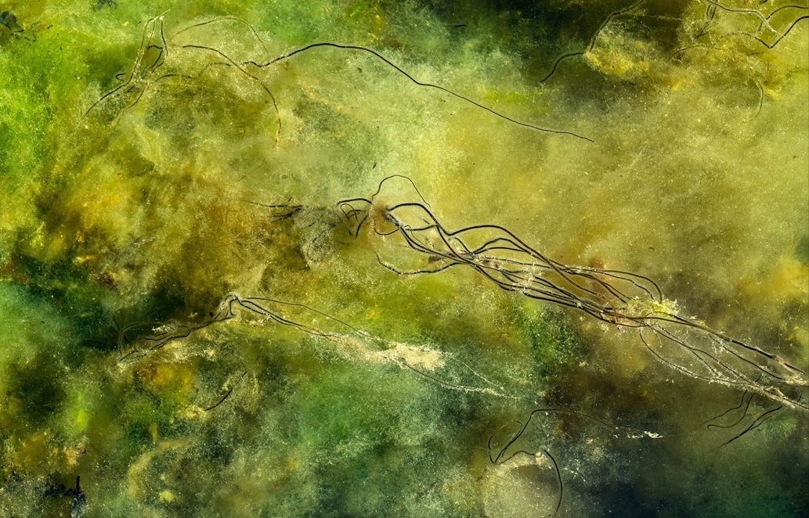
Figure 2. The Dead Man's Rope (Chorda filum) shown in this photograph are about 3.3 ft. high, and the bottom is covered with soft blanket weed (Cladophora glomerata). Photo by W.carter, CC0 1.0 Universal.
Nunc ac magna. Maecenas odio dolor, vulputate vel, auctor ac, accumsan id, felis. Pellentesque cursus sagittis felis. Pellentesque porttitor, velit lacinia egestas auctor, diam eros tempus arcu, nec vulputate augue magna vel risus. Cras non magna vel ante adipiscing rhoncus. Vivamus a mi. Morbi neque. Aliquam erat volutpat. Integer ultrices lobortis eros. Pellentesque habitant morbi tristique senectus et netus et malesuada fames ac turpis egestas.

Chapter Heading 4 (Sub-subheading)
Proin semper, ante vitae sollicitudin posuere, metus quam iaculis nibh, vitae scelerisque nunc massa eget pede. Sed velit urna, interdum vel, ultricies vel, faucibus at, quam. Donec elit est, consectetuer eget, consequat quis, tempus quis, wisi. In in nunc. Class aptent taciti sociosqu ad litora torquent per conubia nostra, per inceptos hymenaeos. Donec ullamcorper fringilla eros. Fusce in sapien eu purus dapibus commodo.

References/Bibliography/Works Cited
Grady, J. S., Her, M., Moreno, G., Perez, C., & Yelinek, J. (2019). Emotions in storybooks: A comparison of storybooks that represent ethnic and racial groups in the United States. Psychology of Popular Media Culture, 8(3), 207–217.
Shulte, Bret. “Putting a Price on Pollution.” US News & World Report, vol. 142, no. 17, 14 May 2007, p. 37. Ebsco, Access no: 24984616.

Appendix/Appendices
Appendix A: List of California State University Campuses
California State University, Bakersfield
California State University Channel Islands
California State University, Chico
California State University, Dominguez Hills
California State University, East Bay
California State University, Fresno
California State University, Fullerton
Humboldt State University
California State University, Long Beach
California State University, Los Angeles
California State University Maritime Academy
California State University, Monterey Bay
California State University, Northridge
California State Polytechnic University, Pomona
California State University, Sacramento
California State University, San Bernardino
San Diego State University
San Francisco State University
San José State University
California Polytechnic State University, San Luis Obispo
California State University San Marcos
Sonoma State University
California State University, Stanislaus

Appendix B: Abbreviations of California State University Campuses
CSU Bakersfield
CSU Channel Islands
Chico State
CSU Dominguez Hills
Cal State East Bay
Fresno State
Cal State Fullerton
Humboldt State
Cal State Long Beach
Cal State LA
Cal Maritime
CSU Monterey Bay
CSUN
Cal Poly Pomona
Sacramento State
Cal State San Bernardino
San Diego State
San Francisco State
San José State
Cal Poly San Luis Obispo
CSU San Marcos
Sonoma State
Stanislaus State

